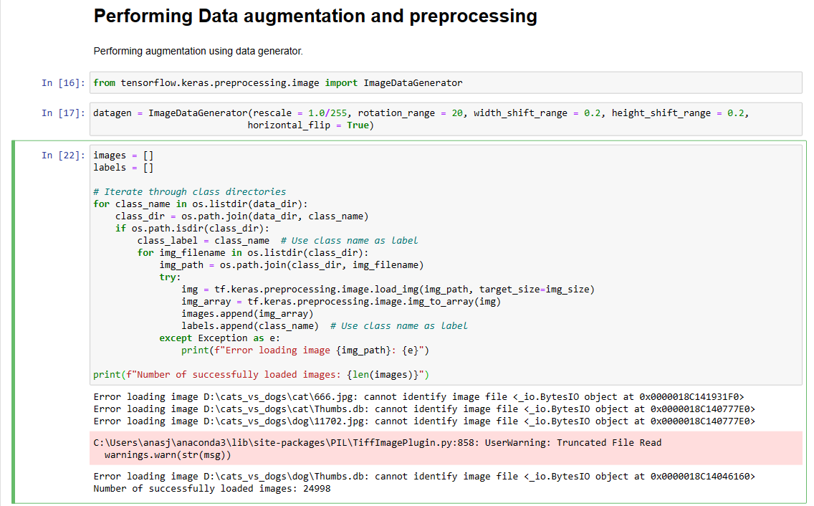

Figure 1: Challenge 1

Challenge 1: Improper and noisy data in the dataset was causing, the prevention of loading the image dataset, the improper images and thumbnail files were identified and were removed from the dataset manually.

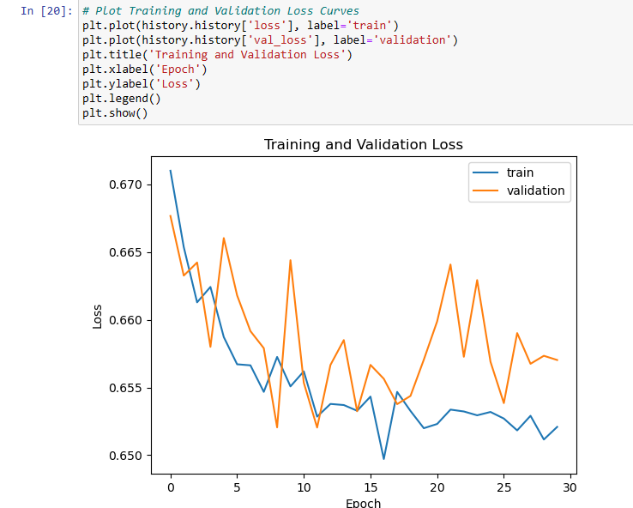

Figure 2: Challenge 2

The Model was initially trained on 30 epochs, since the graph indicates, that after 15 epochs, model started overfitting, the amount of epochs were reduced to 15, then to 10 for better generalization.

Challenge 3: *OOM (Out of Memory)* error was encountered as initially 32 batches of 25000, image of size 224 by 224 was taken. To handle this issue Image size was reduced to 100 by 100, and batch sized were reduced to 8.